Experiment No. 7

**NUMPY**

Programming Assignment Screenshots

**PROBLEM 1:**

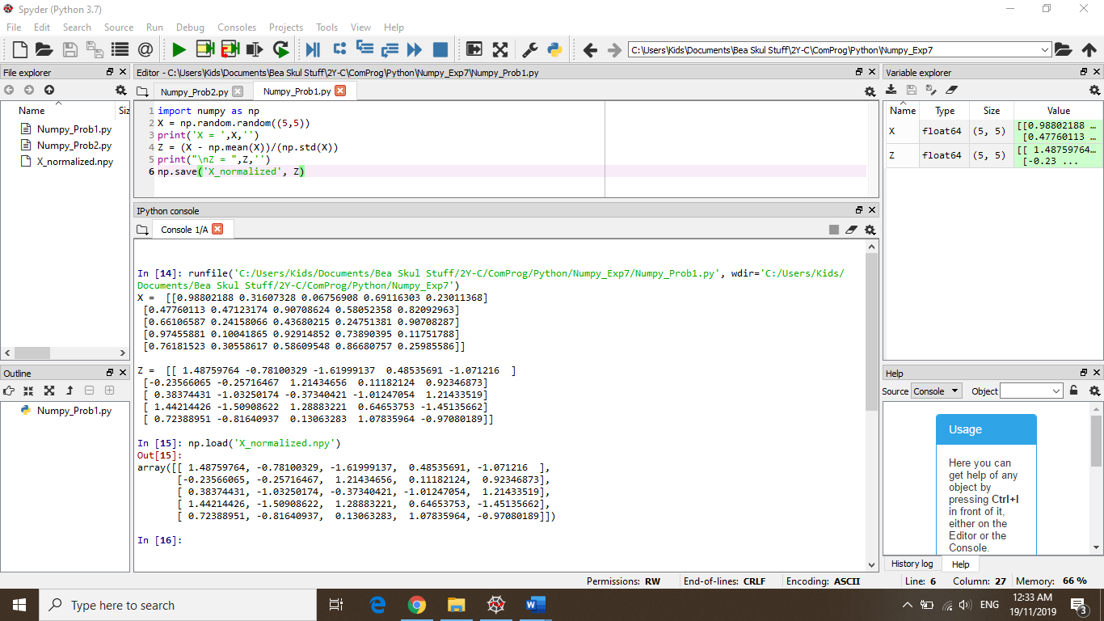

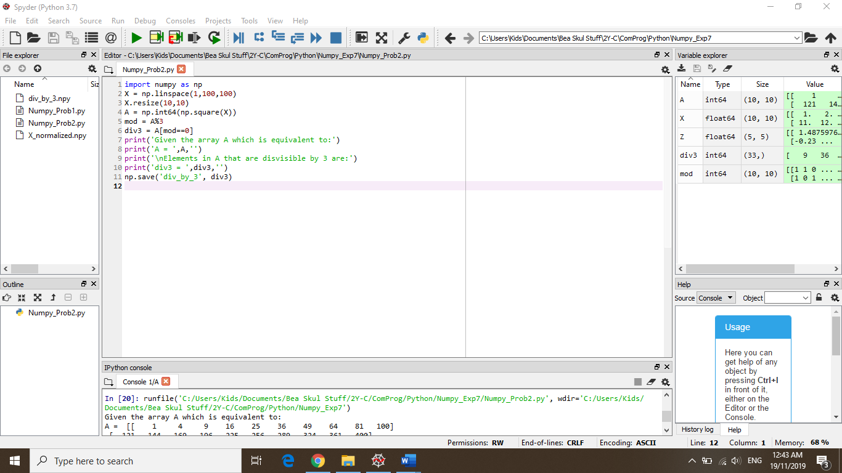**PROBLEM 2:**

